HW #4 Natural Cubic Spline Interpolation

0. Executive Summary
Using natural cubic spline method to get the yield curve, forward rate curve and discount factor curve. In addition, consider the situation of maturity year of 7, the yield is 0.0898962, the forward rate is 0.103784 and the discount factor is 0.532979.
- Statement of Problem
Use interpolation to get continuous function of yield curve from discrete knots. In this task, we take natural cubic spline method to do the interpolation. Then derive the forward rate curve and discount factor from the interpolated yield with different maturities.

- Description of The Mathematics
Natural cubic spline requires following condition:
On each 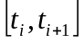, S(x) is a cubic, and have the same first derivative and second derivative at knot point from two sides. In addition the second derivatives at two ending points are set to be 0.
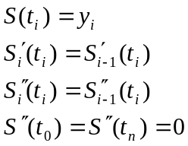
From these conditions that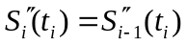 , we can derive the natural cubic spline as below:
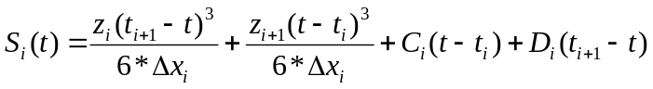
Where:
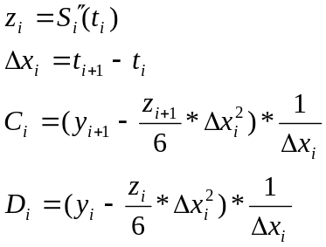
The only unknown parameters here are just n-1 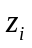’s, and we have n-1 equations because the first derivatives from both sides are equal at each n-1 inner knot plots. Then we can use Gaussian elimination without scaled row pivoting to get the value of each, then we can find the interpolation smooth line S(x).
The Gaussian elimination without scaled row pivoting works like this:
If we define:
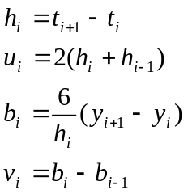
Then the n-1 equations can be presented as determinate：
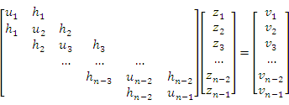

Calculated using the algorithm:
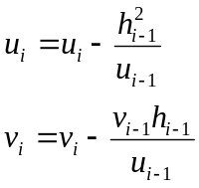
We can get 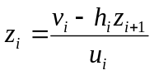

From the interpolation, we can get the value of yield for different maturities. Then from the formula below, we can get the value of forward rate f and discount factor D.
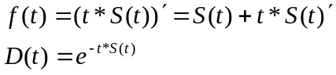

- Description of the Algorithm
The algorithm of Gaussian elimination without scaled row pivoting is listed as below:
First define some variables as below:

Input m, , 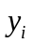, m is the number of total knots, and the upper bound of array is m-1.
For i=0 to m-2 do
=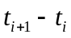
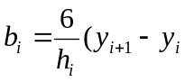)
End do
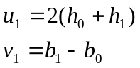
For i=2 to m-2 do
End do
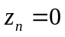
For i=m-2 to 1 step -1 do
End do
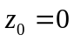
Output

- Results
Maturity(years) | 1 | 2 | 3 | 4 | 5 | 6 | 7
Yield for different maturities | 0.06 | 0.0682 | 0.0747977 | 0.0801 | 0.0843 | 0.0875255 | 0.0898962
Forward rate | 0.069217 | 0.0828305 | 0.0925428 | 0.0989985 | 0.102768 | 0.104192 | 0.103784
Discount factor | 0.941765 | 0.872494 | 0.799001 | 0.725859 | 0.656062 | 0.591465 | 0.532979

Yield curve:
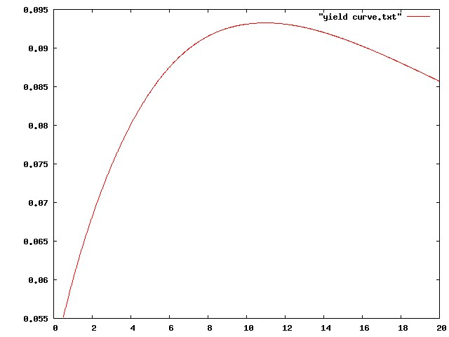

Forward rate curve:
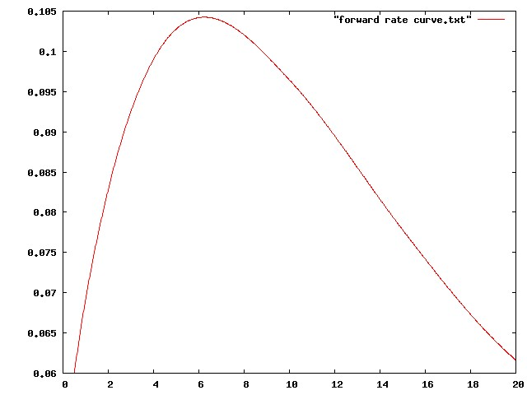

Discount factor curve:
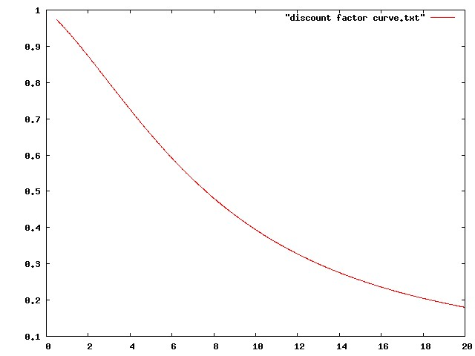

- Conclusions
From the interpolation, we get the continuous function which goes through the given knot points and smooth. In order to get the curve image, I choose 1000 points from 0.5 to 20 with constant interval, compute these values with the interpolated continuous function and line up these points in gnuplot.
Then use the same method to different functions: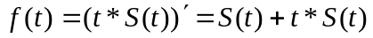, 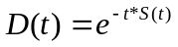 to acquire these other two curves.
- Code Listing

<cubic.h>
#ifndef CUBIC_H
#define CUBIC_H

class Cubic
{
public:
Cubic (int m, double xseris[], double yseris[]);
double getvalue ( double m);
double getfirstderivative ( double m);

private:
int knot_number;
double* t;
double* y;
double* C;
double* D;
double* z;
};
#endif;

<cubic.cpp>
#include "cubic.h"
#include <iostream>
#include <iomanip>
#include <math.h>
#include <fstream>

using namespace std;

Cubic::Cubic(int m, double xseris[], double yseris[])
{
knot_number=m;
t=xseris;
y=yseris;
C=new double[m];
D=new double[m];
z=new double[m];
double* h=new double[m];
double* u=new double[m];
double* b=new double[m];
double* v=new double[m];

for (int i=0;i<=m-2;i++)
{
h[i]=t[i+1]-t[i];
b[i]=6*(y[i+1]-y[i])/h[i];
}

u[1]=2*(h[0]+h[1]);
v[1]=b[1]-b[0];

for (int i=2;i<=m-2;i++)
{
u[i]=2*(h[i]+h[i-1])-h[i-1]*h[i-1]/u[i-1];
v[i]=b[i]-b[i-1]-h[i-1]*v[i-1]/u[i-1];
}

z[m-1]=0;

for (int i=m-2;i>=1;i--)
{
z[i]=(v[i]-h[i]*z[i+1])/u[i];
}

z[0]=0;

for (int i=0; i<m-1;i++)
{
C[i]=(y[i+1]-z[i+1]*h[i]*h[i]/6)/h[i];
D[i]=(y[i]-z[i]*h[i]*h[i]/6)/h[i];
}

delete [] h;
delete [] u;
delete [] b;
delete [] v;

}
double Cubic::getvalue(double m)
{

for (int i=0;i<=(this->knot_number)-2;i++)
{
if ((m>=(this->t)[i])&&(m<=(this->t)[i+1]))
{
return z[i]*pow((t[i+1]-m),3)/6/(t[i+1]-t[i])+z[i+1]*pow((m-t[i]),3)/6/(t[i+1]-t[i])+C[i]*(m-t[i])+D[i]*(t[i+1]-m);
}
}

}

double Cubic::getfirstderivative(double m)
{
for (int i=0;i<=knot_number-2;i++)
{

if ((m>=(this->t)[i])&&(m<=(this->t)[i+1]))
{
return (-1.0/2)*z[i]*(t[i+1]-m)*(t[i+1]-m)/(t[i+1]-t[i])+(1.0/2)*z[i+1]*(m-t[i])*(m-t[i])/(t[i+1]-t[i])+C[i]-D[i];
}
}

}

<main.cpp>
#include "cubic.h"
#include <iostream>
#define _USE_MATH_DEFINES
#include <math.h>
#include <float.h>
#include <fstream>
using namespace std;

int main()
{

double t[8]={0.5,1,2,4,5,10,15,20};
double y[8]={0.0552,0.060,0.0682,0.0801,0.0843,0.0931,0.0912,0.0857};

Cubic a(8,t,y);

ofstream out;

out.open("output.txt");

for (int i=1;i<=7;i++)
{
out<<a.getvalue(i)<<' ';
}
out<<endl;
for (int i=1;i<=7;i++)
{
out<<a.getvalue(i)+i*a.getfirstderivative(i)<<' ';
}
out<<endl;
for (int i=1;i<=7;i++)
{
out<<pow(M_E,(-1)*i*a.getvalue(i))<<' ';
}
out<<endl;
out.close();

out.open("yield curve.txt");
{
for (int i=0;i<1000;i++)
{
out<<0.5+(20-0.5)/1000*i<<' '<<a.getvalue(0.5+(20-0.5)/1000*i)<<endl;
}
}
out.close();

out.open("yield curve original.txt");
{
for (int i=0;i<=7;i++)
{
out<<t[i]<<' '<<y[i]<<endl;
}
}
out.close();

out.open("forward rate curve.txt");
{
for (int i=0;i<1000;i++)
{
out<<0.5+(20-0.5)/1000*i<<' '<<a.getvalue(0.5+(20-0.5)/1000*i)+(0.5+(20-0.5)/1000*i)*a.getfirstderivative(0.5+(20-0.5)/1000*i)<<endl;
}
}
out.close();

out.open("forward rate curve original.txt");
{
for (int i=0;i<7;i++)
{
out<<t[i]<<' '<<a.getvalue(t[i])+t[i]*a.getfirstderivative(t[i])<<endl;
}
}
out.close();

out.open("discount rate curve.txt");
{
for (int i=0;i<1000;i++)
{
out<<0.5+(20-0.5)/1000*i<<' '<<pow(M_E,(-1)*(0.5+(20-0.5)/1000*i)*a.getvalue(0.5+(20-0.5)/1000*i))<<endl;
}
}
out.close();

out.open("discount rate curve original.txt");
{
for (int i=0;i<7;i++)
{
out<<t[i]<<' '<<pow(M_E,(-1)*t[i]*a.getvalue(t[i]))<<endl;
}
}

return 0;
}

